January 22, 2023 – Epiphany 3 (A)
Religious Life Sunday

Are you seeking to deepen your relationship with God and to center your life on Jesus Christ? Are you longing for companionship along the way? Episcopalians living under vows (monks, nuns, sisters, brothers, friars) provide guidance, community, and resources for the sacred journey. We invite you to celebrate Religious Life Sunday and to learn more about the spiritual support that we offer.

What is “Religious Life Sunday”?
The General Convention of The Episcopal Church approved resolution 2022-B004, “Foundation of Religious Life Sunday,” to be held each year on the 3rd Sunday of Epiphany. This Sunday focuses efforts to tell all Episcopalians that residential monastic and dispersed Christian communities exist, who we are, and how to connect with us.

What are the “religious” communities in The Episcopal Church?
Religious communities in The Episcopal Church include monastic communities, whose members live together under a rule of life and under vows such as poverty, chastity, and obedience. “Religious life” also includes dispersed Christian communities whose members are from all walks of life, who have jobs, who live in their own homes, some with families, and who live under religious vows.

What can religious life do for me and for my faith journey?
We have developed traditions and practices that assist in developing spiritual growth and discernment. We teach about prayer practices, lead retreats, give spiritual direction, assist in writing and living a rule of life, give presentations about the spiritual journey, and provide spiritual friendship. Many of our monastic communities offer hospitality for short visits or longer retreats. Religiouslifesunday.org includes resources, a video, a list of speakers, and much more.

You may perceive a call to a deeper commitment with one community, as an associate or oblate. Such commitments begin with discernment and preparation, followed by a formal service of commitment. Associates and oblates pray for the members of the community, as we also pray for them, and may offer financial support, commit to a rule of life, and attend retreats. You or someone you know may be experiencing a call to join a community; we welcome the opportunity to discern with you.
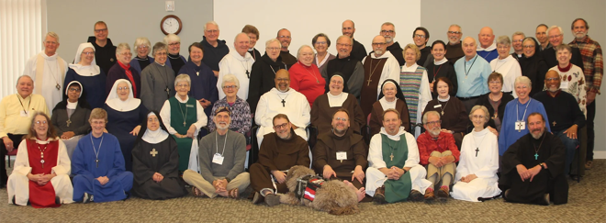
How can I connect with an Episcopal religious community?
Residential monastic communities: caroa.net.
Dispersed Christian communities: naecc.net.
More resources: religiouslifesunday.org.

Collect For Monastic Orders and Vocations
O Lord Jesus Christ, you became poor for our sake, that we might be made rich through your poverty: Guide and sanctify, we pray, those whom you call to follow you under the vows of poverty, chastity, and obedience, that by their prayer and service they may enrich your Church, and by their life and worship may glorify your Name; for you reign with the Father and the Holy Spirit, one God, now and forever. Amen.

