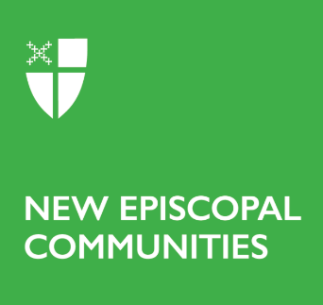

Diocesan Endorsement Form

Growth & Harvest Grant Applications

This endorsement form is intended to be filled out following a conversation between the Point Leader and the Bishop, Canon, or other supervising diocesan leader.

Name of the New Episcopal Community:

Diocese:

Date of meeting with the NEC leader:

Diocesan representative present:

On a separate page, please provide a concise evaluation of the status of this New Episcopal Community (NEC). Topics to cover are:

- How are you maintaining regular contact with this NEC and its point leader?
- What are your plans for continued support, to help build sustainability of the community, and of the financial status of this NEC?
- How have you and the NEC collaborated to set goals and benchmarks?
- What challenges to supporting this NEC, and any other church plants in your diocese, have you found along the way?
- What do you need to see in this New Episcopal Community to feel good about supporting it financially for the long term, after our grant cycle has ended?

Is there anything else you would like to tell us?

__________________________________
Name

__________________________________
Signature and date

