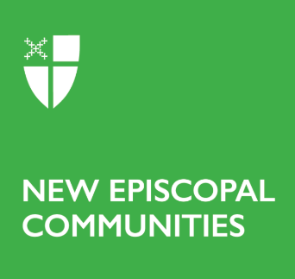

Diocesan Endorsement Form

Discernment & Seed Grant Applications

This endorsement form is intended to be filled out following a conversation between the Point Leader and the Bishop, Canon, or other supervising diocesan leader.

Name of the New Episcopal Community:

Diocese:

Date of meeting with the NEC leader:

Diocesan representative present:

How does this idea for a New Episcopal Community fit into your wider Diocesan vision and strategy for mission?

Tell us about your enthusiasm and support for this vision of a New Episcopal Community.

Tell us about your support and enthusiasm for the mission developer who is leading this initiative.

Has the leader you have commissioned for this work attended a Discerning Missional Leadership Retreat, or other gifts assessment? What did they learn, and what did you learn from your conversation about the feedback they received?

What have you learned from previous church planting initiatives in your diocese?

These NEC grants are not meant to stand alone, but to match Diocesan investment in the vision. What investment (including funding, in-kind resources, parish resources, etc.) does your diocese intend to make in this community?

What do you need to see in this New Episcopal Community to feel good about supporting it financially for the long term, after our grant cycle has ended?

Is there anything else you’d like to tell us?

__________________________________
Name

__________________________________
Signature and date

