April 16, 2023 – Easter 2 (A)
Week 2: Reflections on the Resurrection

During the Easter season, Sermons That Work is pleased to present reflections from some of the newest bishops of The Episcopal Church on the resurrection of our Lord. Check back each week for a brief exploration of how Jesus Christ’s rising from the grave changes everything. To listen to this reflection, scan the QR code on this page and subscribe to the Sermons That Work podcast.

When I was a seminary student, my daily afternoon walk would take me past the historic cemetery on campus. Just outside the large, wrought-iron gates marking the entrance to the cemetery, I remember stumbling upon the stump of an old tree. Given the size of the stump, I imagined that the tree once towered over the cemetery, providing shade and protection against the oppressive heat of the summer sun. I imagined a tree of beauty, dignity, and grandeur, yet all that remained of this glorious tree was a dry and lifeless stump. Several years after my graduation and subsequent ordination, I returned to the seminary and decided to enjoy an afternoon walk along the same well-worn path I had followed as a student. I came upon the cemetery expecting to see the old stump I had stumbled upon years before; however, much to my surprise, a bright green shoot had emerged out of the center of the stump. A new tree was breaking forth out of the old. Where once there was only death and decay, new life was emerging.

During this Easter season, we are celebrating Christ’s victory over death and giving thanks that the gate of everlasting life has been opened to us. However, even as we proclaim, “Alleluia! Christ is risen,” the experience of death and reality of grief remain. We still feel the searing pain of loss. We still experience despair, disappointment, and disillusionment. We still find ourselves longing for the fullness of God’s abundant life. In the midst of this longing, it is the promise of God’s new creation that gives us hope, the promise that God is making all things new (Revelation 21:5). The resurrection of Jesus is a foretaste of God’s promise for all of creation!

The paradox of the spiritual life is that we experience both joy and sorrow, hope and despair, life and death. Every day, we experience the tension between the reality of resurrection and the remnant of death’s domain, which, although defeated, continues to cling to power. Yet, in the midst of this tension, there are signs of God’s new creation all around us, signs of new life and new beginnings. For me, it was the surprise of seeing a bright green shoot emerging out of the center of an old stump that began to open my eyes to the possibilities of new creation. I began to see and experience the power of hope. I began to catch a glimpse of God’s vision of a world healed, renewed, and restored. During this Easter season, where are you seeing signs of God’s new creation? How have you experienced God’s promise of hope breaking forth in your life?

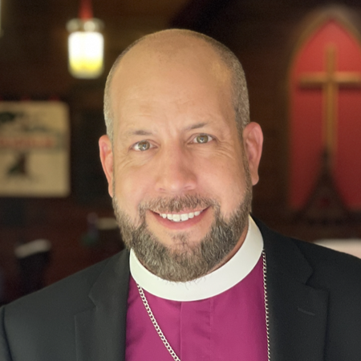
The Sixth Bishop of the Diocese of Southwest Florida, the Rt. Rev. Douglas Scharf leads the diocese where he was raised, ordained, and consecrated. One of the youngest bishops in The Episcopal Church, Bishop Scharf is passionate about discipleship and leadership development. He lives in Parrish with his wife, Shannon, and their three sons.

