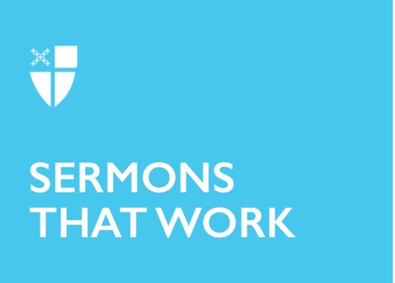

Proper 5 (A)

Proximate
[RCL] Genesis 12:1-9; Psalm 33:1-12; Romans 4:13-25; Matthew 9:9-13, 18-26

Bryan Stevenson, author of Just Mercy, which is now a movie, if you’re not the book-reading type, tells people that what called him into his work was “getting proximate.” Stevenson works with prisoners who are on death row – work he was introduced to in graduate school. He describes being a student at Harvard and beginning work with a law firm – the Southern Center for Human Rights in Atlanta.

His first assignment was to talk with a man on death row – simply informing him that there had been a stay of execution in the case, meaning that this man would not be killed at the date that had been given to him. Stevenson recounts that as he gave this news – what seemed a tiny piece of information – the man had tears in his eyes. He asked for Stevenson to repeat what he’d just heard, to make sure his ears weren’t deceiving him.

Stevenson recounts that this encounter changed him. Prisoners on death row weren’t prisoners anymore – not a faceless mass of criminals – but people. There were stories and names and faces and whole lives lived before the crime for which they had been convicted. Stevenson says that what changed him was this proximity.

Getting proximate seems to be, if not a cure-all, a game-changing thing to do. When we are close to “the other,” however that otherness manifests, we are changed by the relationship – changed by the encounter. We’ve all read stories about people changed by friendships they have across lines of race or socioeconomics or geographical borders. The power of an individual story can’t be denied when we are up close to it.

From this lens, it’s no wonder that Jesus chose to hang out with tax collectors and sinners. He got proximate. Our teacher shows us the way we are to live – to hang out with all kinds of folks, but most especially those who are on the margins of society – those who are judged and misunderstood and “nogood.” Our teacher eats with them because it’s on these margins that the gospel is most alive – and that God is most needed. As Jesus puts it, those who are well have no need of a physician.

So, how do we do it? How do we get proximate to the heartache of the world? A lot of the time, it’s going to mean leaving our church pews. Often, those who sit near us in church are somewhat like us – perhaps they’re bound to us by having kids the same age, or by having similar career paths, or by both serving on the vestry. With whom are you not usually in contact? Who’s at the gas station in need of a hot meal or overwhelmed with childcare on Sunday morning? Who was out too late last night to wake up in time for service? Who’s serving time in the nearest prison? These are the people with whom Jesus calls us into deeper relationship.

From a place of relationship, we are transformed. We are made into the new creation that God wishes for us – changed into something more closely resembling true love. Jesus says that he desires mercy, not sacrifice. We cannot truly understand mercy without sacrificing our judgment, leaving self-righteousness behind in our walk of discipleship. Bryan Stevenson says very simply that, “each of us is more than the worst thing we’ve ever done.” He can say it not because he is delusional about human nature, not because he imagines us to be saints, but because he knows us to be sinners. He has seen the humanity in those whom we have condemned to a life behind bars. He has seen himself in those who are called, simply, “criminals.”

In this morning’s gospel, when the Pharisees ask the disciples, “Why does your teacher eat with tax collectors and sinners?” they meant it to be shaming. They meant it to be embarrassing. They meant to say, “Why isn’t he hanging out with us – the important people? If he’s important, he should be paying mind to us.”

But Jesus stays true to his calling. He isn’t swayed by the self-importance of the Pharisees. He isn’t tempted into putting himself above anyone else. He knows that there is little difference between the Pharisees and the tax collectors – the only difference was one of ego. One group knew their need of God – the other didn’t.

Jesus says he comes to call not the righteous but sinners – and the good news is that’s us! Sin isn’t confined to those who have broken the law or to those who are different from us. We, too, are sinners. When we get proximate to those who are different from us, what falls away is judgment, allowing us to see how God is working in their lives, and wonder anew about how God might be working in our own.

We are invited in the gospel to check our ego at the door, to get close to those about whom we have judgments, to remember that they – and we! – are more than the worst things anyone has ever done. Amen.

The Rev. Jazzy Bostock is a strong, proud, kanaka maoli woman. She serves two small parishes on the west side of Oahu, one Episcopal and one Lutheran. She and her wife tend to a small garden together, delighting in the way food grows. She loves to laugh, walk barefoot, cook, and feel the sun on her skin.

