July 23, 2023 – Pentecost 8 (A)

The Feast of St. James, Apostle and Martyr

On July 25th, the Church celebrates the Feast of St. James, apostle and martyr.

This James is often styled “St. James the Greater,” to distinguish him from the other Apostle of the same name and from James, “the brother of our Lord.” Along with his brother John, James was called by Jesus at the Sea of Galilee as they mended nets with their father, Zebedee, and his hired hands. St. James is named regularly during major events in the Gospels, witnessing the Transfiguration of Christ (Matthew 17; Mark 9; Luke 9), the raising of Jairus’ daughter (Mark 5, Matthew 9; Luke 8), and Jesus’ agony in the garden (Matthew 26; Mark 14; Luke 22).

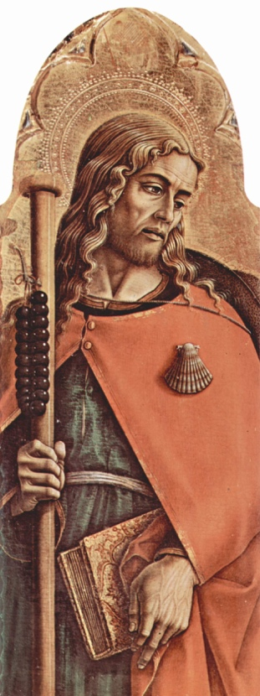
For all this honor, though, James also receives correction from Jesus on more than one occasion. He and his brother are given the nickname “Sons of Thunder,” or Boanerges, for their zealous and temperamental dispositions. For example, when Samaritan villagers refused to welcome Jesus, the brothers eagerly asked whether he would have them call down fire from heaven to destroy the town. The Lord rebukes them and instead moves on to another village (Luke 9). The Gospels record the brothers (or perhaps their mother) asking the Lord to place them at his right and left hands in his kingdom, which also results in admonishment (Matthew 20), and James is among the apostles who fall asleep in the garden while Jesus prays (Matthew 26; Mark 14; Luke 22).

Still, James’ dedication to Jesus is without question, as he is understood to be the first of the twelve to die for him. As the Acts of the Apostles records, “About that time Herod the King laid violent hands upon some who belonged to the Church. He killed James the brother of John with the sword” (Acts 12:1–2).

Holy Women, Holy Men explains the veneration of and devotion to St. James following his death: “According to an old tradition, the body of James was taken to Compostela, Spain, which has been a shrine for pilgrims for centuries” (p. 484). His name was translated from the Hebrew Ya’akov to the Spanish Iago; thus, “Saint James” becomes “Santo Iago,” or “Santiago.” Santiago de Compostela was an extraordinarily popular destination for pilgrimages, leading to the development of the Camino de Santiago, a route across the countryside, marked by the fisherman’s symbol of a scallop shell.

Collect for St. James
O gracious God, we remember before you today your servant and apostle James, first among the Twelve to suffer martyrdom for the Name of Jesus Christ; and we pray that you will pour out upon the leaders of your Church that spirit of self-denying service by which alone they may have true authority among your people; through Jesus Christ our Lord, who lives and reigns with you and the Holy Spirit, one God, now and for ever. Amen.
St. James the Greater, Altarpiece of Mount San Martino; Carlo Crivelli, c. 1480.

