August 6, 2023 – Transfiguration Sunday

The Feast of the Transfiguration
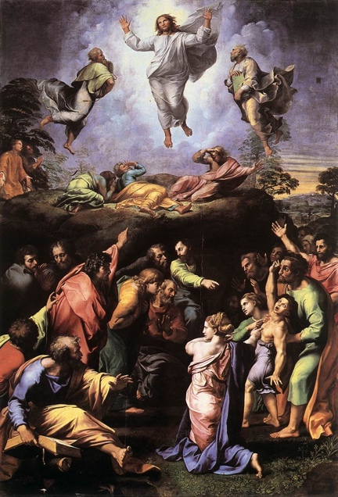
August 6 is the Feast of the Transfiguration of Our Lord Jesus Christ, which commemorates Jesus’ unveiling as the Son of God, and his radical change of appearance while in the presence of Peter, James and John on a mountaintop.

The Gospel of Matthew records that Jesus “was transfigured before them, and his face shone like the sun, and his garments became white as light.” At this moment Moses and Elijah appeared, and they were talking with Jesus. Peter, misunderstanding the meaning of this manifestation, offered to make three “booths” (or “dwellings”) for Jesus, Moses, and Elijah. A bright cloud overshadowed them and a voice from the cloud stated, “This is my beloved Son, with whom I am well pleased; listen to him.” The disciples fell on their faces in awe, but Jesus encouraged them to arise and “have no fear.” When the disciples looked up, they saw only Jesus (Matthew 17:1-8).

The Transfiguration is also mentioned in two other gospel accounts (Mark 9:2-8 and Luke 9:28- 36) and is referred to in the Second Letter of Peter, which records that “we were eyewitnesses of his majesty” and “we were with him on the holy mountain” (2 Peter 1:16-18).

The Transfiguration is a pivotal moment because it revealed Christ’s glory prior to the crucifixion, and it anticipated his resurrection and ascension. It also prefigures the glorification of human nature in Christ. Some think that the setting on the mountain is significant because it becomes the point where human nature meets God, with Jesus acting as a point of connection between heaven and earth.

Celebration of the Transfiguration began in the eastern church in the late fourth century. The feast is celebrated on August 6, which is the date of the dedication of the first church built on Mount Tabor, which is traditionally considered to be the “high mountain” of the Transfiguration. There are scholars, however, who believe the Transfiguration occurred either on Mount Hermon, which borders Syria and Lebanon, or on the Mount of Olives in Jerusalem.

Collect for the Transfiguration
O God, who on the holy mount revealed to chosen witnesses your well-beloved Son, wonderfully transfigured, in raiment white and glistening: Mercifully grant that we, being delivered from the disquietude of this world, may by faith behold the King in his beauty; who with you, O Father, and you, O Holy Spirit, lives and reigns, one God, for ever and ever. Amen (Book of Common Prayer, p. 243).

