July 16, 2023 – Pentecost 7 (A)
UTO Awards

More than $1 million in United Thank Offering grants was designated for 22 projects related to the worldwide incarceration crisis within The Episcopal Church and Anglican Communion. The funds came from the United Thank Offering’s 2022 Ingathering, where monies collected in UTO “blue boxes” at Episcopal churches throughout the year are gathered as thank offerings. This year’s focus for grant applications was projects addressing the worldwide incarceration crisis, specifically preventative programs and intervention, prisoner support outreach, prison reform work, or post-prison reentry.

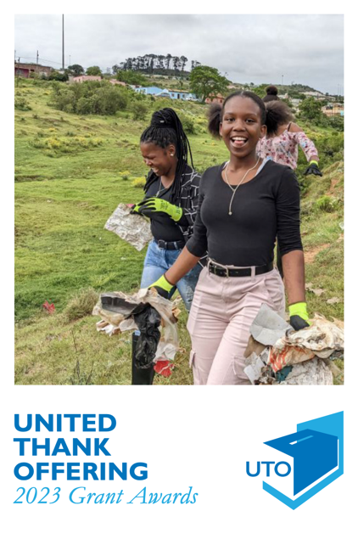
“The worldwide incarceration crisis affects us all, whether or not we know someone directly affected by incarceration,” said UTO Board President Sherri Dietrich. “Jesus’ words in Matthew 25 and the Way of Love encourage us to work for justice in the world and to respect the dignity of every human being, including prisoners and their families. The grants UTO funded this year will create that ministry in new places around the world.”

Below are some of the projects funded by the UTO in 2023. Find the whole list at iam.ec/uto2023en.

July 16, 2023 – Pentecost 7 (A)
UTO Awards

More than $1 million in United Thank Offering grants was designated for 22 projects related to the worldwide incarceration crisis within The Episcopal Church and Anglican Communion. The funds came from the United Thank Offering’s 2022 Ingathering, where monies collected in UTO “blue boxes” at Episcopal churches throughout the year are gathered as thank offerings. This year’s focus for grant applications was projects addressing the worldwide incarceration crisis, specifically preventative programs and intervention, prisoner support outreach, prison reform work, or post-prison reentry.

“The worldwide incarceration crisis affects us all, whether or not we know someone directly affected by incarceration,” said UTO Board President Sherri Dietrich. “Jesus’ words in Matthew 25 and the Way of Love encourage us to work for justice in the world and to respect the dignity of every human being, including prisoners and their families. The grants UTO funded this year will create that ministry in new places around the world.”

Below are some of the projects funded by the UTO in 2023. Find the whole list at iam.ec/uto2023en.

Well Time 2.0: Empowering Reentry
Des Moines, Iowa, $22,048
Well Time 2.0: Empowering Reentry will recruit/prepare volunteers from churches to provide faith-based support to women recently released from prison through weekly group meetings at the Waterloo Women’s Center for Change and through individual reentry teams for women to offer compassionate guidance to overcome personal, societal, and economic barriers.

Partner for Success
Elkridge, Maryland, $31,408
Partner for Success is a faith-based mentoring program designed to help those who are incarcerated make a smooth transition back into society in the greater Baltimore, Maryland, area. Participants are matched with a mentor and a worship community to establish short- and longterm plans –of action for successful reentry back into society.

Sowing Love and Education
Eloy Alfaro, Canton Manta, Ecuador $79,604.14
Construction of the Child Care Center, which provides comprehensive and integral care to children from 3 months to 5 years old of incarcerated persons. The center will promote integral development of minors and their abilities, guarantee a safe and caring environment, initial education, psychological care, and support for families who take care of them.

Compassionate Anglicans Youth Republic Project of Campo Verde
Missionary District, Brazil: $55,000
This project is to create the Compassionate Anglicans Youth Republic Project , which will provide support, subsidized housing, and job training/work to a group of 10 young men who have aged out of shelters, are in vulnerable situations, have broken or extremely fragile family ties, and who do not have the means for self-sustenance.

Well Time 2.0: Empowering Reentry
Des Moines, Iowa, $22,048
Well Time 2.0: Empowering Reentry will recruit/prepare volunteers from churches to provide faith-based support to women recently released from prison through weekly group meetings at the Waterloo Women’s Center for Change and through individual reentry teams for women to offer compassionate guidance to overcome personal, societal, and economic barriers.

Partner for Success
Elkridge, Maryland, $31,408
Partner for Success is a faith-based mentoring program designed to help those who are incarcerated make a smooth transition back into society in the greater Baltimore, Maryland, area. Participants are matched with a mentor and a worship community to establish short- and longterm plans –of action for successful reentry back into society.

Sowing Love and Education
Eloy Alfaro, Canton Manta, Ecuador $79,604.14
Construction of the Child Care Center, which provides comprehensive and integral care to children from 3 months to 5 years old of incarcerated persons. The center will promote integral development of minors and their abilities, guarantee a safe and caring environment, initial education, psychological care, and support for families who take care of them.

Compassionate Anglicans Youth Republic Project of Campo Verde
Missionary District, Brazil: $55,000
This project is to create the Compassionate Anglicans Youth Republic Project , which will provide support, subsidized housing, and job training/work to a group of 10 young men who have aged out of shelters, are in vulnerable situations, have broken or extremely fragile family ties, and who do not have the means for self-sustenance.

