September 17, 2023 – Pentecost 16 (A)
Episcopal Service Corps Program Spotlight: Plainsong Farm & Ministry

Plainsong Farm & Ministry is an Episcopal Service Corps program in Rockford, Michigan, dedicated to cultivating connections between people, places, and God. By making a place that nurtures belonging and the radical renewal of God’s world, Plainsong Farm is a living laboratory where fellows can experiment with how to pray, belong, grow, rest, serve, and play.

Plainsong Farm is currently recruiting Corps members between the ages of 21 and 32 for its 2023-2024 program year. Over nine months, Plainsong Fellows will experience:

- A balanced life of prayer, feasts, play, rest, study, conversation, retreats, and work
- Immersion in regenerative agriculture and conservation practices for health and healing of all creation
- Weekly evening formation gatherings which include cooking farm-fresh meals, Christian scripture, hands-on activities, contextual analysis of power, possession, people, and place, both in history and today, and doing the dishes
- Conflict resolution coaching
- Monthly field trips
- Life in community with one another and the various intergenerational communities of Plainsong Farm
- Lots of cucumbers
- And embodied practice

Dates of service: January 14, 2024 to November 1, 2024
Weekly commitment: 32 work hours per week, 8 formation hours per week
Compensation: $425 monthly stipend, housing on the farm, utilities, end-of-service award, health insurance, spiritual direction, and seasonal vegetables. This leads to a total estimated value of $12,000.

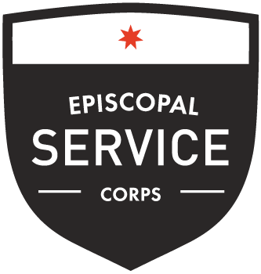
About Episcopal Service Corps
Now in its 23rd year, Episcopal Service Corps (ESC) is built on the belief that change happens when we bring together diverse teams of committed and passionate young leaders ages 21-32 and support them as they tackle some of our nation’s most difficult challenges. Find out more about Plainsong Farm at https://www.plainsongfarm.com/. Learn about Episcopal Service Corps at https://episcopalservicecorps.org, and apply today at https://episcopalservicecorps.org/apply/.

