September 10, 2023 – Pentecost 15 (A)
Welcoming Young Adults into Your Congregation

Whoever welcomes one such child in my name welcomes me. - Matthew 18:5

“If we lose a generation of young people in the church, it won’t be because we didn’t entertain them. It will be because we didn’t dare to do something meaningful with the Gospel in light of the world we live in.” – Shane Claiborne

Young adults (18-30 years old) enrich our communities with a variety of gifts, experiences, and perspectives. You may have heard a lament that young adults aren’t coming to church. We want them to be part of the life of the church, but where and how do we engage in ministry with them? The inclusion of young adults in the life of the church requires a sincere and intentional invitation, welcome, and inclusion.

Welcome and Relationship
Young adults want to be treated and welcomed just as anyone else. Introduce yourself, be attentive, and respect their boundaries. Strike up a conversation without assuming things because of their age. “Hi. My name is ____. I don’t think we’ve met.” “Tell me about yourself and what brought you here today.” “Can I introduce you to my friend?”

Community and Empowerment
Young adults experience a variety of transitions and a community of faith creates an atmosphere of support and belonging. From this sense of community, young adults will seek ways to live out their Christian calling. We have an obligation to empower young adults in their lives in Christ and how they might be feeling called to engage.

Mentoring Environments
The presence of young adults in our parishes provides them an opportunity to engage with God through the Episcopal tradition and experience. A mentoring parish recognizes, challenges, supports, inspires, and engages young adults in order to foster their faith. The prophetic voice of young adulthood can challenge the church to more fully live into its calling as the body of Christ.

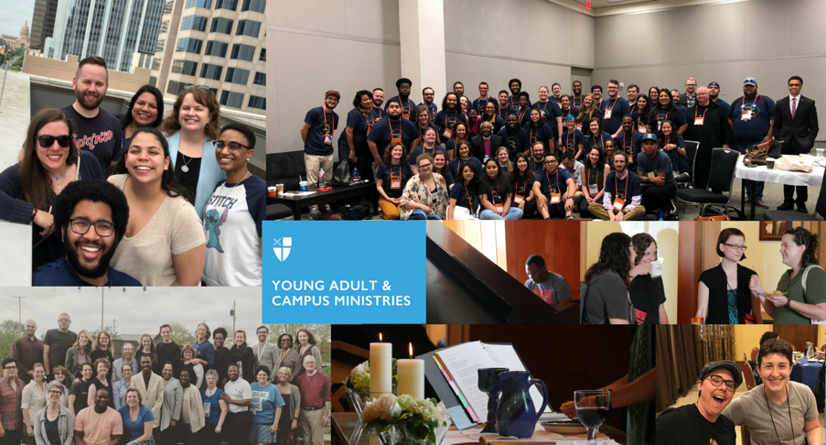
Our Responsibility to Young Adults
We are called to share the wealth and worth of the Christian story with young adults and hear what the Christian story means to them. We must engage young adults in honest and sophisticated conversation about God and the calling and value of every human being. We must equip young adults with the tools of our tradition for facing the tough ethical, moral, ecological, relational, and religious challenges of the broader world.

For more information about ministry with Young Adults, visit episcopalchurch.org/yacm.

