October 29, 2023 – Pentecost 22 (A)
Meet Your Episcopal Service Corps Programs: On Sacred Ground - Wyoming Service Corps

Through Wyoming Service Corps, an Episcopal Service Corps (ESC) program in Cody, Wyoming, young adults share a contemplative environment to discern their greater place in the world and explore the natural and social world around them.

Service
Corps members serve 32 hours a week at a variety of community organizations in the area. Because we are a small community in which nonprofit organizations have limited funds to pay staff, a corps member may serve part time at multiple sites.

The volunteer site placements are oriented to social and environmental justice as well as social welfare, providing opportunities for the growth of each participant vocationally, personally, and spiritually.

Community
Wyoming Service Corps members call Thomas the Apostle Center (TAC) home. TAC is a spiritual retreat center that provides communal living space complete with a chapel, labyrinth, and a Stations of the Cross/prayer walk up Dinosaur Ridge, against which TAC is built. This sacred space has served as a place of healing, rejuvenation, and growth for thousands over the years.
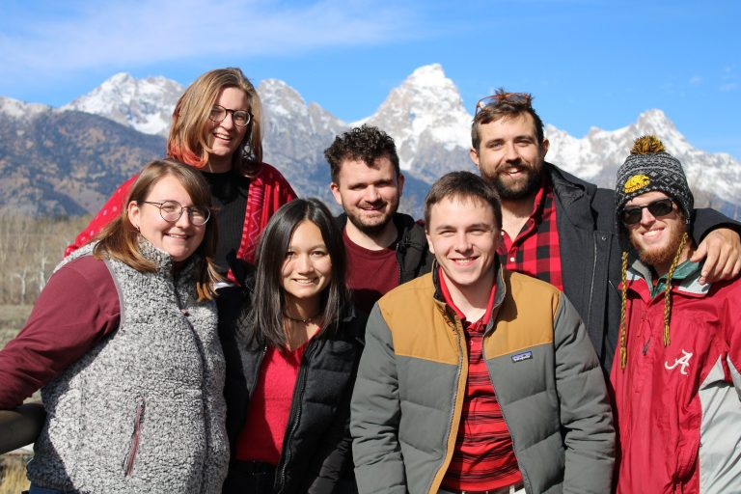
Corps members share rooms, a kitchen, dining area as well as common areas for meeting, gathering, and play. The entire campus was originally built by an artist, and there is a small gallery in the Studio House as well. One of the rooms is handicapped accessible.

Corps members receive health insurance, subsidized therapy, spiritual direction, mentoring, housing, internet, utilities and a $250 a month personal stipend, $900 collective food monies, $400 collective transportation monies.

Spiritual Life
It is in looking after others that we find our best selves. Where do we fit in this world? What is a task that we can undertake that will help us bring our world closer to the kingdom of God on earth? Through On Sacred Ground’s 10-month program, corps members explore these questions and more through spiritual direction, daily and weekly devotions, worship, discernment, and time spent in personal reflection in Cody and in the greater region of Wyoming’s natural beauty.

Applications for the 2024-2025 Corps will open December 1. Visit ESC’s website to learn more about On Sacred Ground – Wyoming Service Corps or to take the ESC Discernment Quiz, EpiscopalServiceCorps.org.

