October 1, 2023 – Pentecost 18 (A)
Evangelism Grants

Episcopal institutions are invited to apply for evangelism grants to support local and regional efforts to grow Episcopal ministries, resources, and gatherings. The application deadline is Oct. 13.

The grant application, criteria, requirements, budget information, and more are available online in English, Spanish, and French: https://iam.ec/evangelismgrants.

The grants committee will consider proposals for up to $2,000 for individual faith communities and up to $8,000 for multichurch, diocesan, provincial, and other regional collaborations. A total of $125,000 is available for this funding cycle.

The 2023 grant focus is on evangelism initiatives that minister across barriers. Projects that would fit this theme include the following:

- Collaborative, lay-led ministries that are not clergy dependent.

October 1, 2023 – Pentecost 18 (A)
Evangelism Grants

Episcopal institutions are invited to apply for evangelism grants to support local and regional efforts to grow Episcopal ministries, resources, and gatherings. The application deadline is Oct. 13.

The grant application, criteria, requirements, budget information, and more are available online in English, Spanish, and French: https://iam.ec/evangelismgrants.

The grants committee will consider proposals for up to $2,000 for individual faith communities and up to $8,000 for multichurch, diocesan, provincial, and other regional collaborations. A total of $125,000 is available for this funding cycle.

The 2023 grant focus is on evangelism initiatives that minister across barriers. Projects that would fit this theme include the following:

- Collaborative, lay-led ministries that are not clergy dependent.

- Ministries that explicitly support and include communities traditionally underrepresented in The Episcopal Church.
- Ministries that engage new ways of being the church in new spaces.

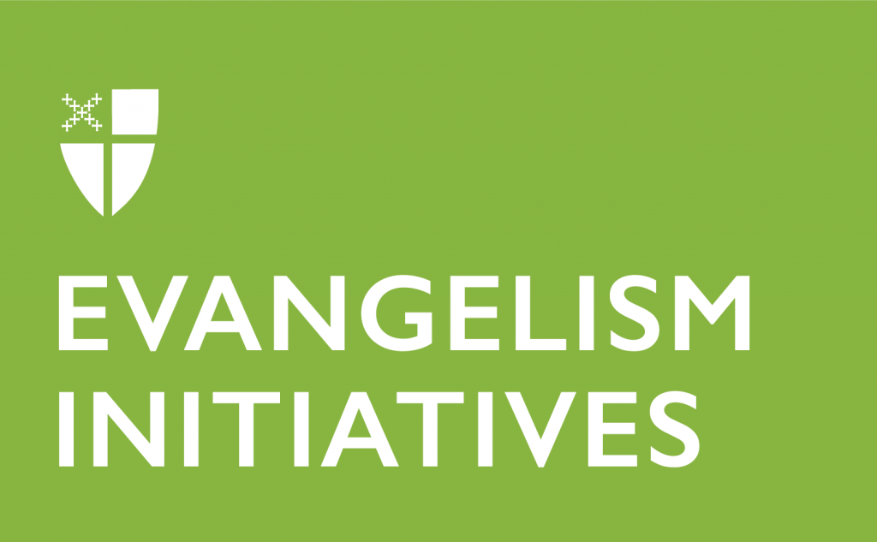
“Presiding Bishop Michael Curry has noted that evangelism is not about building bigger churches but rather about building a better world,” said Jerusalem Greer, manager of evangelism and discipleship. “The same is true for this evangelism grant cycle; we are looking for applicants and projects committed to sharing the Good News of God in Christ in ways that build relationships, heal brokenness, and invite people to create a better world together.”

The Episcopal Evangelism grants program began in 2017 in response to the 2015 General Convention’s increased investment in evangelism. The program is coordinated by the Executive Council Joint Standing Committee on Mission Within The Episcopal Church in collaboration with evangelism staff. During the 2018-2 021 triennium, 12 Episcopal communities were awarded grants, out of 59 applicants.

- Ministries that explicitly support and include communities traditionally underrepresented in The Episcopal Church.
- Ministries that engage new ways of being the church in new spaces.

“Presiding Bishop Michael Curry has noted that evangelism is not about building bigger churches but rather about building a better world,” said Jerusalem Greer, manager of evangelism and discipleship. “The same is true for this evangelism grant cycle; we are looking for applicants and projects committed to sharing the Good News of God in Christ in ways that build relationships, heal brokenness, and invite people to create a better world together.”

The Episcopal Evangelism grants program began in 2017 in response to the 2015 General Convention’s increased investment in evangelism. The program is coordinated by the Executive Council Joint Standing Committee on Mission Within The Episcopal Church in collaboration with evangelism staff. During the 2018-2 021 triennium, 12 Episcopal communities were awarded grants, out of 59 applicants.

