September 24, 2023 – Pentecost 17 (A)
United Thank Offering Grants

The United Thank Offering Board is pleased to announce the availability of its 2024 UTO Annual Grants, with a focus on projects that welcome and include “the stranger.” Application deadlines are Dec. 1 for Anglican Communion partners and Jan. 19 for dioceses of The Episcopal Church.

More information—including criteria for applicants, sample budgets and timelines, and helpful hints—as well as application and other forms are available online in English and Spanish here: https://unitedthankoffering.com/apply/. Instructional videos created by the UTO grants committee will be posted online.

In addition, informational webinars will be held throughout the fall, as well as monthly open office hours for staff to work directly with applicants on their materials. Dates and registration links are available here: https://iam.ec/uto2024dates.

This is the second of a three-year United Thank Offering grant focus on those whom society has left out and behind, in the spirit of Matthew 25:36. The 2023 grants—recently approved—support 22 projects related to the worldwide incarceration crisis. The 2024 grants will fund projects that welcome people with differences that cause isolation and that encourage truth-telling, acknowledging historic trauma, and establishing a path toward healing.

Applications may be submitted in advance of the deadlines for review and feedback. Learn more about the United Thank Offering, a ministry of The Episcopal Church: https://unitedthankoffering.com/.
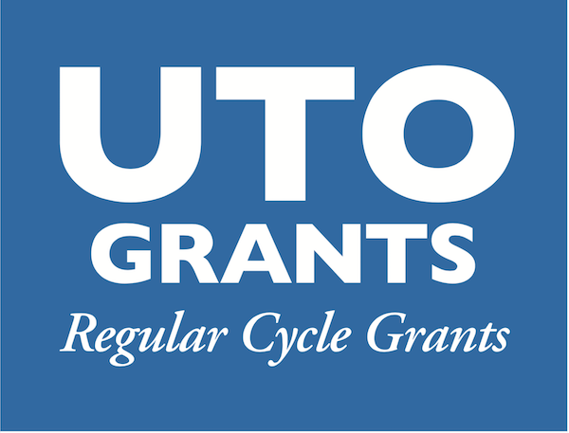
The United Thank Offering (UTO) is a ministry of The Episcopal Church for the mission of the whole church. Through UTO, individuals are invited to embrace and deepen a personal daily spiritual discipline of gratitude. UTO encourages people to notice the good things that happen each day, give thanks to God for those blessings and make an offering for each blessing using a UTO Blue Box. UTO is entrusted to receive the offerings, and to distribute the 100% of what is collected to support innovative mission and ministry throughout The Episcopal Church and Provinces of the Anglican Communion.

