October 8, 2023 – Pentecost 19 (A)
Young Adult and Campus Ministry Grants

Episcopalians are invited to consider how their community might serve young adults—on and off college campuses—and apply for an Episcopal Church Young Adult and Campus Ministry grant for the 2024-25 academic year.

The deadline to apply is Nov. 13, with decisions announced in early 2024. Applicants are encouraged to use a discernment and planning guide prior to submission. Find application forms, selection criteria, sample applications, a timeline, budget guidelines, and more here: iam.ec/yacmgrants.

A total of $140,000 is available for awarding in four grant categories to eligible dioceses, congregations, and/or college and university ministries that engage in or are seeking new relationships with young adults.

Applicants are asked to include a 1- to 2-minute video explaining how this grant would help their ministry grow, change, or do something new. Grant categories include the following:

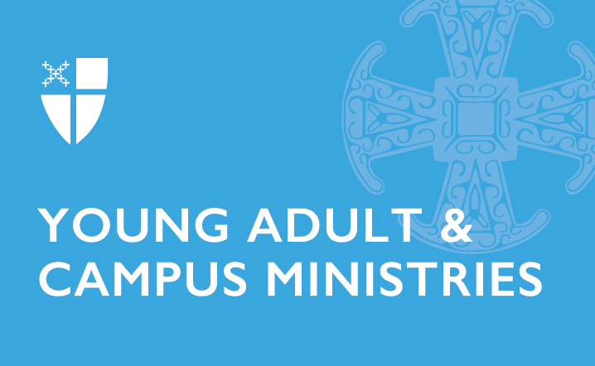
- Development grants: Establish new, restore a dormant, or reenergize an existing ministry. Grants range from $8,000-$30,000; can be used over two years; and can only be awarded to a specific ministry once every five years.
- Campus ministry grants: Provide seed money to help in the startup of new, innovative campus ministries or to enhance an existing ministry. Grants $1,000-$8,000.
- Young adult ministry grants: Provide seed money to help in the startup of new, innovative young adult ministries or enhance existing ministries. Grants $1,000-$8,000.
- Project grants: Provide money for a one-time project to enhance and positively impact a campus or young adult ministry. Grants $100-$2,000.

During last year’s grant cycle, 20 grants were awarded to ministries from dioceses across the U.S. and Cuba.

“The Young Adult and Campus Ministry grants enable communities throughout the church to dream about what is possible, what is next, and where God is calling their ministry to do a new thing,” said the Rev. Shannon Kelly, director for the Department of Faith Formation and officer for Young Adult and Campus Ministries. “As we continue to think creatively about what church looks like, these grants enable our young adults, ministers, congregations, and dioceses to dream big and learn more about themselves and their communities.”

For more information, contact the Rev. Shannon Kelly: skelly@episcopalchurch.org.

