February 11, 2024 – Last Sunday in Epiphany (B)

The Absalom Jones Fund

What is the Absalom Jones Fund?
The Absalom Jones Fund for Episcopal HBCUs supports two institutions affiliated with The Episcopal Church since the 1800s: Saint Augustine’s University in Raleigh, North Carolina, and Voorhees University in Denmark, South Carolina.

In 1804, Absalom Jones became the first African American to be ordained a priest in The Episcopal Church. His witness to the way of Jesus included efforts to abolish slavery and to lift up all those cast down. He understood that education is the key to empowerment. We honor Absalom Jones by supporting our HBCUs, which prepare the talented leaders who will continue the work of building a more just and humane society.

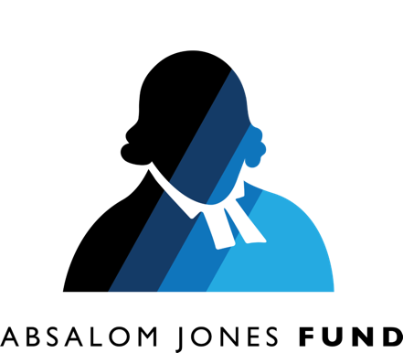
What is an HBCU?
Historically Black colleges and universities (HBCUs) were founded to create dynamic, supportive, and empowering educational environments for young people from diverse backgrounds. Today there are more than 100 HBCUs in the

February 11, 2024 – Last Sunday in Epiphany (B)

The Absalom Jones Fund

What is the Absalom Jones Fund?
The Absalom Jones Fund for Episcopal HBCUs supports two institutions affiliated with The Episcopal Church since the 1800s: Saint Augustine’s University in Raleigh, North Carolina, and Voorhees University in Denmark, South Carolina.

In 1804, Absalom Jones became the first African American to be ordained a priest in The Episcopal Church. His witness to the way of Jesus included efforts to abolish slavery and to lift up all those cast down. He understood that education is the key to empowerment. We honor Absalom Jones by supporting our HBCUs, which prepare the talented leaders who will continue the work of building a more just and humane society.

What is an HBCU?
Historically Black colleges and universities (HBCUs) were founded to create dynamic, supportive, and empowering educational environments for young people from diverse backgrounds. Today there are more than 100 HBCUs in the

United States, including public and private institutions and professional schools of law and medicine.

According to a study published by the United Negro College Fund, today’s historically Black colleges and universities are responsible for producing approximately 70 percent of all Black doctors and dentists, 50 percent of Black engineers and public school teachers, and 35 percent of Black lawyers.

Why support our Episcopal HBCUs?
Voorhees University and Saint Augustine’s provide an excellent liberal arts education to thousands of students, the majority of whom come from low-income households, and over 40% of whom are the first in their families to attend a four-year college. The Gospel work of education and emancipation, evangelism and formation, reconciliation and commitment to a just and humane society and world is happening at these schools! Yet in today’s economic and political climate, HBCUs increasingly struggle to secure the funds they need to maintain their facilities, retain excellent faculty, and provide much-needed student financial aid.

Collect for the Feast of Absalom Jones
Set us free, heavenly Father, from every bond of prejudice and fear; that, honoring the steadfast courage of your servant Absalom Jones, we may show forth in our lives the reconciling love and true freedom of the children of God, which you have given us in your Son our Savior Jesus Christ; who lives and reigns with you and the Holy Spirit, one God, now and for ever. Amen.

United States, including public and private institutions and professional schools of law and medicine.

According to a study published by the United Negro College Fund, today’s historically Black colleges and universities are responsible for producing approximately 70 percent of all Black doctors and dentists, 50 percent of Black engineers and public school teachers, and 35 percent of Black lawyers.

Why support our Episcopal HBCUs?
Voorhees University and Saint Augustine’s provide an excellent liberal arts education to thousands of students, the majority of whom come from low-income households, and over 40% of whom are the first in their families to attend a four-year college. The Gospel work of education and emancipation, evangelism and formation, reconciliation and commitment to a just and humane society and world is happening at these schools! Yet in today’s economic and political climate, HBCUs increasingly struggle to secure the funds they need to maintain their facilities, retain excellent faculty, and provide much-needed student financial aid.

Collect for the Feast of Absalom Jones
Set us free, heavenly Father, from every bond of prejudice and fear; that, honoring the steadfast courage of your servant Absalom Jones, we may show forth in our lives the reconciling love and true freedom of the children of God, which you have given us in your Son our Savior Jesus Christ; who lives and reigns with you and the Holy Spirit, one God, now and for ever. Amen.

